SmartVision AI: Intelligent Multi-Class Object Recognition System
Domain: Computer Vision & Artificial Intelligence
Frameworks Used: Python, Streamlit, PyTorch / TensorFlow, OpenCV, Ultralytics (YOLOv8)
1. Executive Summary & Problem Statement
Object detection and classification are foundational capabilities in computer vision, powering diverse real-world applications from autonomous vehicles to smart retail, wildlife conservation, and traffic monitoring. However, building robust systems that can accurately identify and locate multiple objects across various domains remains a significant challenge.
Organizations across industries need intelligent systems that can:
- Accurately detect and classify objects from diverse categories (vehicles, animals, household items, food, people, etc.)
- Handle real-world complexity with multiple objects present in single images
- Provide fast inference suitable for real-time applications
- Demonstrate reliability across different lighting conditions, angles, and contexts
- Scale efficiently for cloud-based deployment
SmartVision AI addresses these challenges by delivering an end-to-end computer vision pipeline combining multi-architecture Image Classification (Transfer Learning) and real-time Object Detection.
2. Project Objectives
- Data Preprocessing Pipeline: Create an automated workflow to resize, normalize, and augment image datasets safely.
- Multi-Model Image Classification: Train and evaluate four state-of-the-art Deep Learning convolutional networks (VGG16, ResNet50, MobileNetV2, and EfficientNetB0) using Transfer Learning.
- Advanced Object Detection: Integrate YOLOv8 to locate and bound multiple concurrent object categories within a single visual frame.
- Performance Optimization: Apply optimization strategies such as model quantization and batch inference processing to maximize prediction speeds.
- Interactive Interface & Cloud Deployment: Build a production-ready interactive dashboard using Streamlit and host it globally using cloud services.
3. System Architecture & Technical Workflow
The system is built upon a modular architecture dividing tasks into data handling, model inferencing, performance tracking, and user interactions.

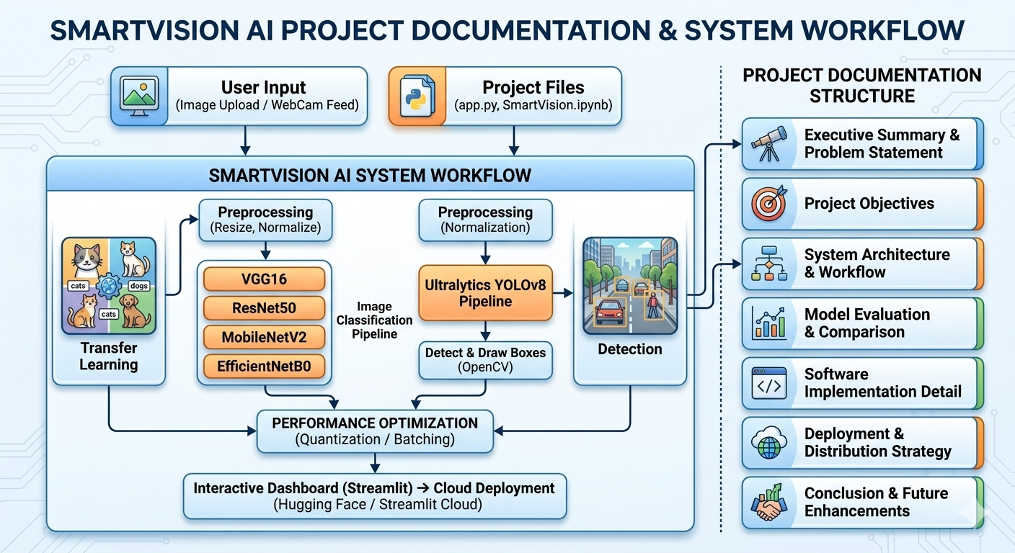
- Phase 1: Data Preparation: Pipelines ingest source images, perform dimensions mapping, apply normalization metrics matching underlying pretrained models, and bundle records into optimal inference batches.
- Phase 2: Image Classification (Transfer Learning): Leverages feature spaces of pre-trained architectures to perform categorizations without requiring training convolutional structures from scratch.
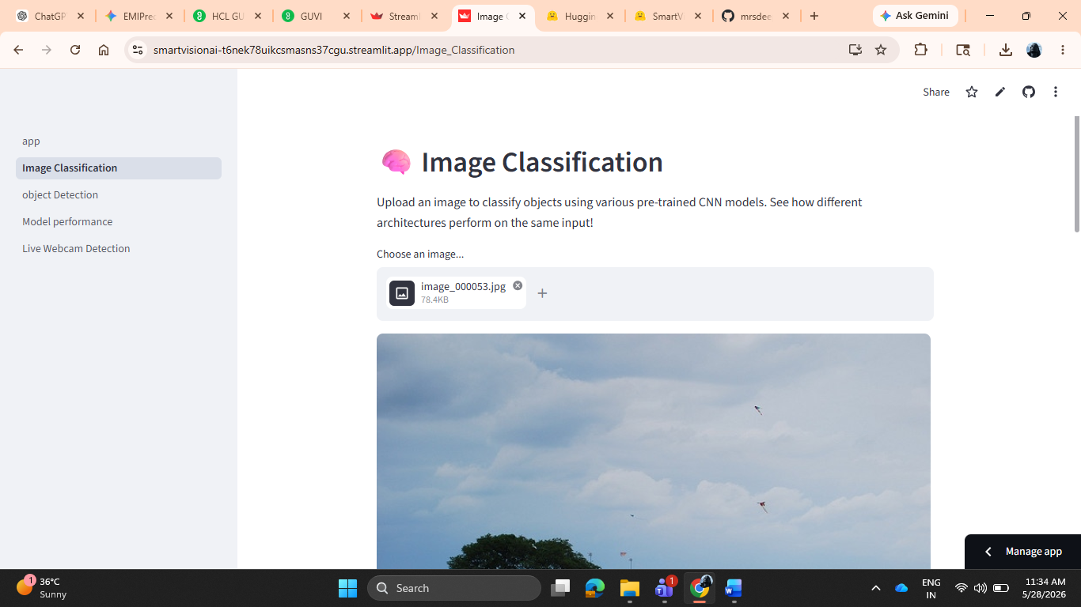
- Phase 3: Real-Time Object Detection: Executes YOLOv8 to generate object localization matrices (bounding boxes) and object confidence scoring metrics simultaneously across frames.
- Phase 4: Optimization Engine: Enhances throughput via weights transformation (quantization layers) and continuous request packing to decrease target system latency.
4. Model Evaluation & Comparison
Based on the experiments conducted within the training environment, the following strengths and operational metrics were observed across the evaluated models:
Model Architecture | Accuracy Rating | Inference Speed / Latency | Compute Footprint | Primary Use Case
VGG16 | High Feature Depth | Slowest | Very Heavy | High-fidelity static environments
ResNet50 | Excellent (Deep Residuals) | Moderate | Heavy | Complex or fine-grained datasets
MobileNetV2 | Good Efficiency | Extremely Fast | Light / Low Memory | Mobile & edge deployment environments
EfficientNetB0 | State-of-the-art Balance | Fast | Highly Balanced | Scalable production cloud ecosystems
YOLOv8 | Exceptional Detection | Real-time Throughput | Dependent on Variant | Multi-object tracking and bounding
5. Software Implementation Detail
The final application is structured to run as a multi-page dashboard built using Streamlit. The code architecture splits functionalities cleanly across specific script endpoints:
- app.py: Serves as the central homepage entry point, setting initial canvas bounds, configuring expanded side navigation menus, and displaying basic platform feature workflows.
- pages/1_Image_Classification.py: Manages model initialization for VGG16, ResNet50, MobileNetV2, and EfficientNetB0, accepts customer file uploads, and graphs classification probabilities.
- pages/2_Object_Detection.py: Initializes the YOLO context engine to parse images, draws bounding coordinates overlay shapes via OpenCV, and labels confidence data.
- pages/3_Model_performance.py: Renders telemetry analytical data tables, system processing speeds, and infrastructure utilization details.
6. Deployment & Distribution Strategy
To expose the application to end-users without local python environments, the containerization and cloud structure were verified across target pipelines:
- Containerization (Dockerfile): Uses a clean python:3.11-slim footprint, injecting system-level graphic modules (libgl1, libglx-mesa0, libglib2.0-0) required to execute OpenCV operations in a headless environment.
- Target Cloud Platforms: Ready for deployment to Streamlit Community Cloud or Hugging Face Spaces (Docker SDK variant) mapped explicitly to standard server porting flags (--server.port=7860, --server.address=0.0.0.0).
7. Conclusion & Future Enhancements
The SmartVision AI platform successfully demonstrates that combining deep transfer learning classification networks with specialized single-stage object detectors (YOLOv8) yields a fast, reliable, and production-ready intelligence application.
Future versions of this system will look to integrate:
- Continuous tracking across streaming live RTSP security camera feeds.
- Fine-tuning foundational models on proprietary, domain-specific industry datasets.
- Incorporating model distillation to downscale model sizes further for hyper-local micro-edge processors.

